Unit 5:
Sound Investigation

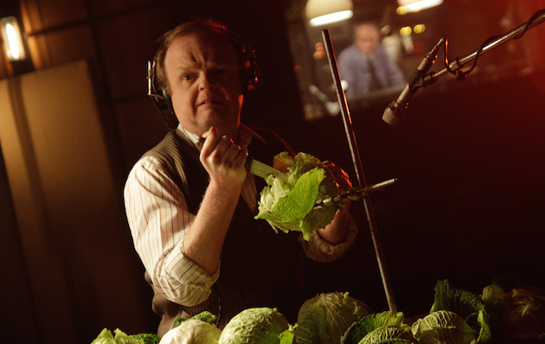

Level 3 Creative Media

Student Name


Sound Investigation
You have four weeks to conduct ONE sound investigation.

PART ONE – The Problems

There are four audio-based problems. You must pick one of the problems below to solve, working individually or in pairs. There will be specific guidance for each problem.

The problems are:

1. The WWF Charity have commissioned a 2 minute 39 second animated short but they are unhappy with the audio design. They need completely new audio that show cases the sounds of nature (plants and animals) in the sequence instead of just music. This involves you working to write and record a suitable voice over, record Foley sound, library sounds, SFX and copyright free music.

2. Film Four have two clips (choose one) from The Thing (Carpenter, 1982) and The Fly (Cronenberg, 1987) for a horror documentary they are going to show in a late night slot. These clips have no sound or dialogue. This involves you working to write and record suitable dubbing, Foley sound, library sounds, SFX and copyright free music.

3. Radio 1 currently have terrible ratings for their breakfast show. They have decided to take on a brand new, unknown DJ for this slot. Create a 5-minute audition radio segment that show cases your DJ skills. You should create an entertaining segment that would interest Radio 1 listeners and get you a job.

4. Radio Four are worried that young people are not listening to radio drama anymore. They are looking for a brand new drama to attract a teen audience. Develop an idea for a one off 30-minute long drama, write the script for the opening 5 minutes and then record the opening of your episode. You must add sound effects and (if you can) record your own theme music.

PART TWO- Analysing the problem

After you have chosen your “problem” you must analyse it and work out how to solve it.
You will explore key sound recording terms and work out if they will be useful to you in solving your audio problems. There are five main jobs to do here:

- You must write a glossary that explains the following terms: Studio sound recording and location sound recording, stationary and moving sound, Foley, Ambient sound, sound effects, music, drama dialogue, contrapuntal sound
- You must complete a “what microphones” worksheet exploring different audio technology
- Research the target audience for your problem. Carrying our primary and secondary research.
- Research the role of a Foley artist as well as the copyright laws you would have to abide by if you had recorded your sound professionally.
- Use your glossary and your research produce a detailed plan to show how you will solve your chosen audio problem. Which recording techniques will you use? Which equipment? How long will it take? How will you use sound to appeal to your target audience?

(Unit 5, 1.1, 1.2)
PART THREE-Solving your problem

Complete the relevant planning and paperwork for your chosen specific audio-based problem.

WWF Film and Horror Film Re-Dubs

- Choose your clip

- Analyse your clip and make a list of all the sounds you need

- Decide which sounds you will record and which to get from libraries

- Write an explanation of your main decisions. How does your sound plan match the director’s original intentions? How does it meet the needs of the client?

- Collect your sounds this must be logged using the Foley and sound effects log sheet

- Add them to your chosen clip and export a QuickTime version of the film

Radio 1 Skills Show Case and Radio 4 Drama

- Research target audience

- Research current topics that would interest radio 1 or radio 4 listeners

- Write a script (Using appropriate radio scripting format)

- Book radio station (See Greig)

- Fill out any relevant radio paperwork (Recording schedule, contributor consent forms, risk assessments, crew and cast lists)

- Record segment in radio station.

(Unit 5, 2.1, 2.2)

Part Four – Evaluating your Solution

Evaluate your solution to the audio-based problem. This can be presented either as a 500 word written evaluation or 10-minute presentation.

You should cover the following areas:

- Explore your brief analysis of original clip or problem.
- Have you addressed the needs of the target audience? How?
- How did your solution meet your original intentions?
- What types of sound did you use? How were they successful? How did you solve the problem?
- What are the strengths and weaknesses of your work?
(Unit 5, 3.1)

Final Deadline – Friday 14th December

